**Team Name:** SJ Softball

**Mission**: Combat isolation by supporting a softball team of veterans and first responders

**Vision**: Put together a softball team to create an environment of relaxation and growth for the service member community and their support system.

**Value**: The star in our fireteam logo represents the five principles of ethical leadership, which encompass our value system. The five principles are as follows: Respect Others, Serve Others, Shows Justice, Manifests Honesty, & Builds Community.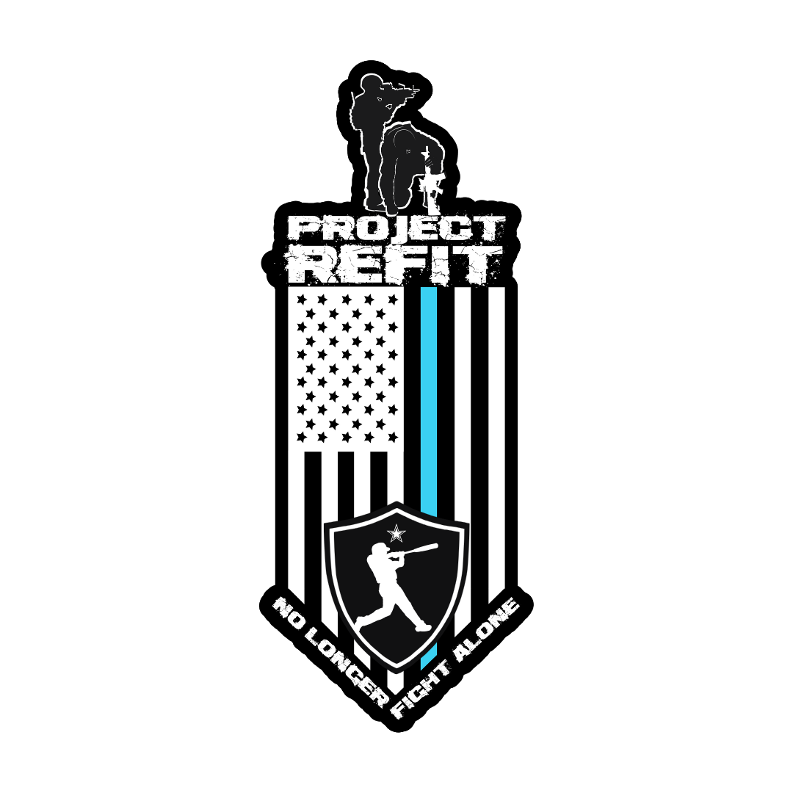

**Items cleared for purchase**:

* Fireteam Gear
* Supplies
  + Wood
  + Firepits
  + Extinguishers
  + Matches (i.e., fire making supplies)
* League Fees
* Bringing in additional veterans
  + Flights
  + Hotels
  + Etc.
* Advertisement
* Rentals
* Food
* Drinks (NO ALCOHOL)
  + Coffee
  + Water
  + Sports drinks
  + Soda
  + etc.
* Cigars

**Team**:

[nicholas locilento](mailto:nloc55@yahoo.com)